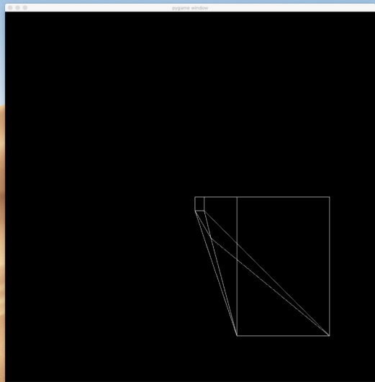

This is a 3D cube with a four-faced pyramid on the bottom of it(this is the assignment sample object; my coordinate system begins at the top-left of the screen) projected into 2D space using perspective projection. The large rectangle on the right makes up the cube facing closest to the user, while the small rectangle in the top-left of the shape is the cube face furthest from the user. This makes sense because the large rectangle’s z-coordinates are the smallest, and therefore, should be closest (largest) in the user’s view, while the small rectangle’s z-coordinates are the largest, and therefore, should be the furthest (smallest) in the user’s view. The closest and furthest rectangles connect to make the cube via an edge from each of their four corners (top-left to top-left, top-right to top-right, bottom-left to bottom-left, bottom-right to bottom-right).

The pyramid’s four triangle faces can be seen intersecting from the bottom corners of both the closest and furthest cube face.

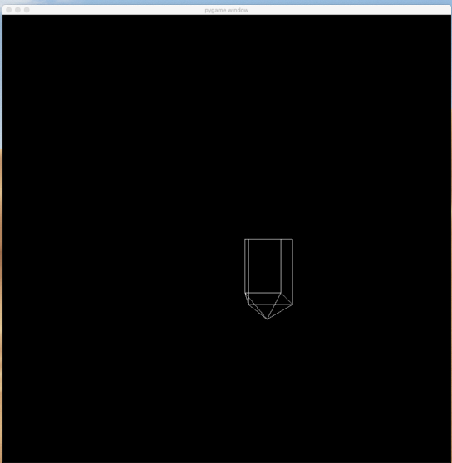

The shape is more clearly visible if its 3D coordinates are translated 400 units in the z direction and then scaling the x and y coordinates by 16. The reason for the image's shape appearing less distorted is, because by scaling the x and y coordinates, the z axis has a less great effect on the image. Translating the image further away from the user (in the z direction) simply allows the image to be scaled without exiting the user’s viewport.

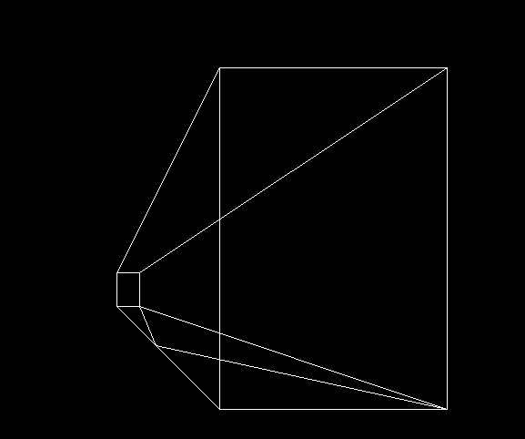

When translating the y-coordinate by -100 units (or up 100 units, for the user), pieces of the shape that are further away from the user (with a larger z-coordinate) are less noticeable altered, while pieces of the shape that are closer to the user (with a smaller z-coordinate) are more noticeably altered. This is why the result appears to be flipped across the horizontal axis.



This is the shape translated 200 units in the z direction. It appears much smaller because it has been translated further from the user’s view. It retains the clearer form that I mentioned previously for the same reason.

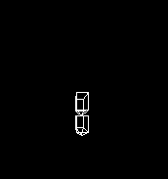

This is 2 of the same shape. Both have been translated 200 units in the z direction. The top shape has also been translated -200 units in the y direction. Like displayed before, the cube face is noticeably more affected by the translation than the further cube face but unlike before, though this shape was translated even further in the y direction, it appears to be less affected and unflipped across the x-axis. The reason for this is because it has been translated so far in the z direction.

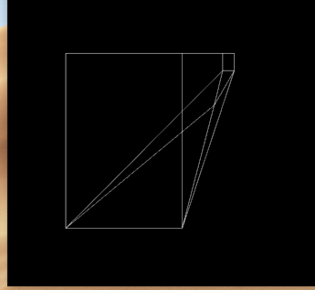

This is the shape translated -200 units in the x direction. As you can see, it has a similar effect to translating in the y direction, where the pieces of the shape closer to the user’s view are more affected by the translation, visualily, and therefore, are flipped over the y-axis.

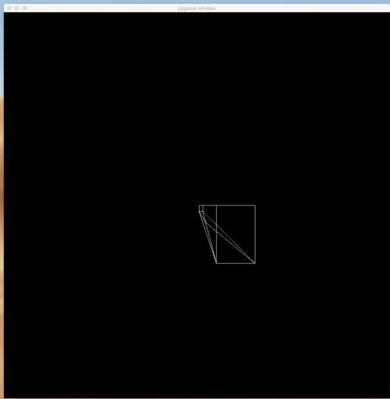

This is the shape when the distance the user is from the screen is reduced from 2.5cm to 1cm. The image appears smaller because the projection is based on similar triangles, and therefore, the same angle. By having to travel less distance to plot the point, each plot is plotted in a narrower range which causes the image to be projected smaller.

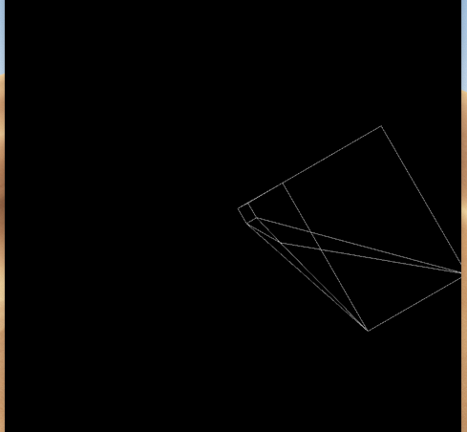

This is the shape rotated -30° in the z direction. This is the rotation that most people would think of when they think of rotating a 3D object.

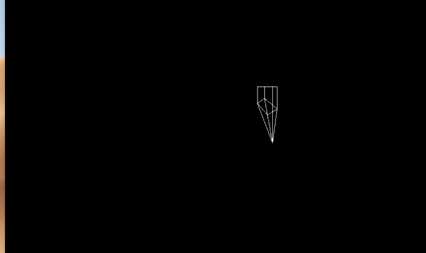

This is the shape rotated -30° in the y direction. The shape grows smaller.

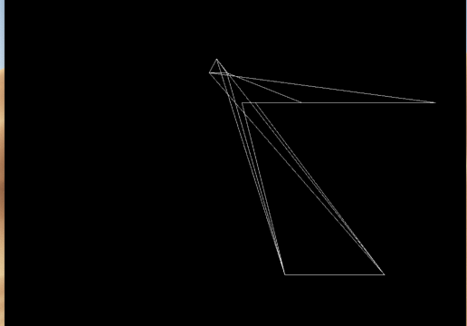

This is the shape rotated -30° in the x direction. This distorts the shape drastically.

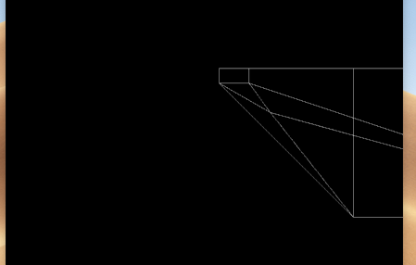

This is what happens if you scale the shape by 3 in the x direction. In this example, the shape extends off the screen but the interesting thing to note is that the shape extends only in the positive direction. It also makes the shape wider.

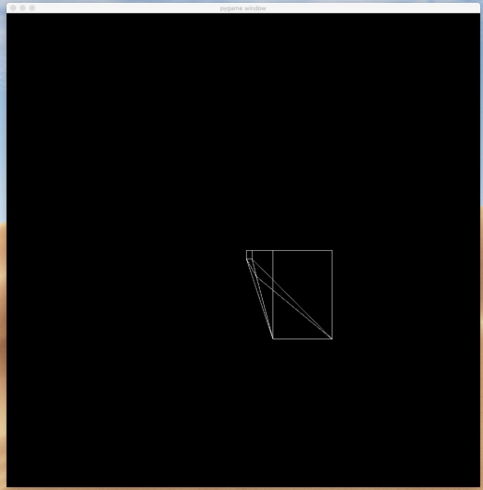

This is the shape if the screen's size is changed from 100 (S = 50) to 200 (S = 100). The shape appears smaller in comparison to the larger screen.

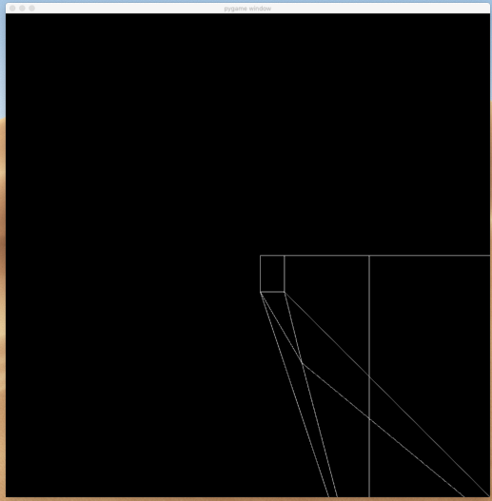

This is the shape if the screen's size is changed from 100 (S = 50) to 50 (S = 25). The shape appears larger in comparison to the larger screen. In this case, the shape extends outside the screen.

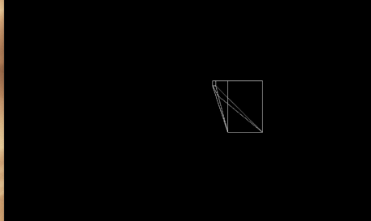

This is what happens when you scale the shape’s z-coordinate by 3. The shape appears smaller because all points are further from the user’s perspective, and the shape appears longer because there is greater distance between the closer points and the farther points.

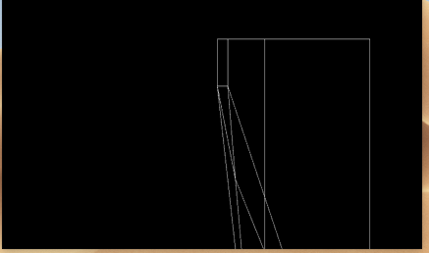

This is what happens if you scale the shape by 3 in the y direction. In this example, the shape extends off the screen but the interesting thing to note is that the shape extends only in the positive direction (which is down). It also makes the shape taller.